**Weighing the Milky Way**

The Milky Way appears to extend about 10 kiloparsecs (50,000 light years) out from the center. Beyond that distance, the density of stars and gas drops off, although a few more distance stars can be found. The total mass of stars and gas (MStars+Gas) in the Milky Way is observed to be about 1011 times the mass of the Sun, all contained within a disk of radius 10 kiloparsecs.

According to Newton’s Law of Gravity, the velocity of stars orbiting far from the galaxy should be proportional to the square root of the total mass divided by the distance from the center.

$$V=2x{10}^{-3}\sqrt{M/R}$$

In this equation M is the mass of the Galaxy, in units of solar masses, and R is the distance from the center of the Galaxy in kiloparsecs. V is the velocity in kilometers per second.

Compute the velocity that stars or globular clusters orbiting the galaxy should have at distances of 10, 12, and 16 kiloparsecs from the Galactic center. Enter them in the table below.

|  |  |  |
| --- | --- | --- |
| Distance (in Kpc) | Mass Enclosed | Predicted Orbital Velocity in km s-1 |
| 10 | 1011 solar masses |  |
| 12 | 1011 solar masses |  |
| 16 | 1011 solar masses |  |

The graph on the next page is a plot of the observed velocity of stars orbiting around the center of the Milky Way, as a function of distance from the Galactic Center. Astronomers call a plot like this a “rotation curve.” Stars orbit the Galaxy following Newton’s Law of Gravity, and their orbital speed depends on the total mass contained inside their orbit. The orbital velocities of stars rise quickly from the center as we move out in radius. This is because the center of the Galaxy is dense, so that the mass inside a circle rises quickly with increasing orbital radius. Further out, the density of stars is less, so the mass contained inside a given radius increases more slowly, and the rotation curve flattens out. The wobbles in the curve are due to the spiral arms

Plot the predicted velocities you calculated above on the observed rotation curve of the Milky Way.

How does the observed orbital speed of distant stars around the center of the Milky Way compare to your prediction based on Newton’s Law of Gravity?

From the graph, what is the observed orbital speed of stars at a distance of 16 kiloparsecs from the Galactic Center?

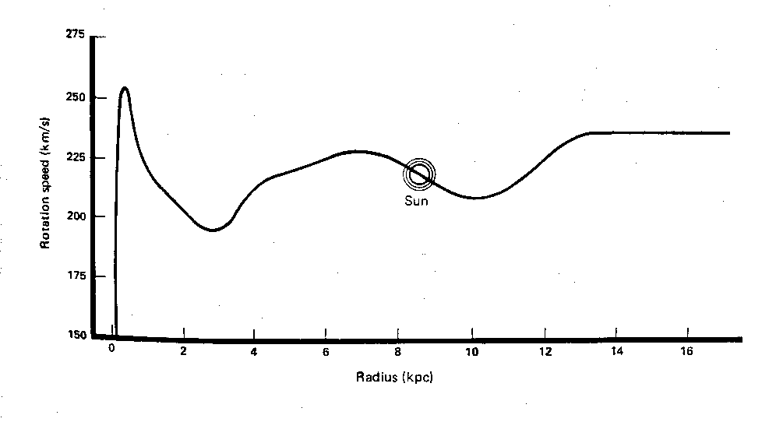

Use observed speed (V) at a distance of 15 kiloparsecs and Newton’s Law of Gravity to compute the mass that would be needed to account for the observed orbital speed, MTotal. (The equation below is the same one as above, just rearranged for your convenience.)

$$M_{Total}=\frac{V^{2}R}{4x{10}^{-6}}$$

Compute the ratio of the total mass to the observed mass of stars and gas

$\frac{M_{Total}}{M_{Stars+Gas}}$ =

**Dark Matter!** The extra mass needed to account for the orbital speeds of stars and globular clusters in the outer fringes of the Milky Way is known as the Galaxy’s “missing mass.” The Galaxy does not contain enough stars or gas to account for the strength of its gravity. A great amount of additional, unseen mass must be present, but not in the form of stars or gas.