**Spiral Structure in the Milky Way**

In the figure on page 2, mark the positions of the hot hydrogen clouds in the table below (use a different color than for the globular clusters). Hot hydrogen clouds are associated with regions of active star formation. The clouds listed below are taken from a 2009 paper by L. D. Anderson and T. M. Bania (Astrophys. J., 690, 706-719). They surveyed the sky with galactic longitudes from 15 to 60 degrees, covering only a portion of the sky.

|  |  |  |  |  |  |  |
| --- | --- | --- | --- | --- | --- | --- |
| **Catalog No** | **Longitude** | **Distance** |  | **Catalog No** | **Longitude** | **Distance** |
| U24.75-0.20a | 24.75 | 3.1 |  | C24.14+0.12 | 24.14 | 8.7 |
| C46.50-0.25 | 46.5 | 4 |  | U28.61+0.02b | 28.61 | 9 |
| C18.95-0.02 | 18.95 | 4 |  | C33.42+0.00 | 33.42 | 9.4 |
| U23.27+0.08 | 23.27 | 5 |  | C26.98-0.07 | 26.98 | 10.2 |
| C27.31-0.14 | 27.31 | 5.6 |  | U37.75-0.10 | 37.75 | 10.4 |
| C24.30-0.15b | 24.3 | 5.7 |  | U35.58-0.03 | 35.58 | 10.6 |
| C28.44+0.00 | 28.44 | 5.9 |  | U48.61+0.02 | 48.61 | 10.7 |
| U32.15+0.13 | 32.15 | 6.2 |  | D29.14-0.04 | 29.14 | 11.5 |
| C24.81+0.10 | 24.81 | 6.4 |  | C30.47-0.04a | 30.47 | 11.8 |
| U33.92+0.11 | 33.92 | 7.1 |  | U18.66-0.06 | 18.66 | 12.5 |
| U28.25+0.01 | 28.25 | 7.6 |  | U43.17+0.00 | 43.17 | 12.7 |
| D50.86+0.08 | 50.86 | 8 |  | U21.87+0.01 | 21.87 | 13.7 |
| U28.61+0.02a | 28.61 | 8.6 |  |  |  |  |

[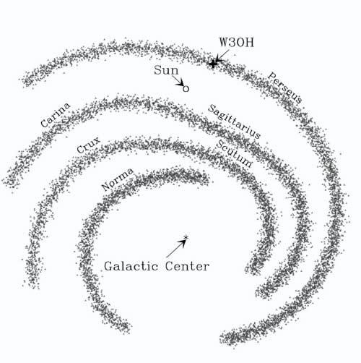](http://www.google.com/url?sa=i&rct=j&q=&esrc=s&frm=1&source=images&cd=&cad=rja&docid=d0g_yHTyDggzeM&tbnid=3nyo6bNdQSiF4M:&ved=0CAUQjRw&url=http://www.newscientist.com/article/dn8436-spiral-arm-of-milky-way-looms-closer-than-thought.html&ei=bOk0Udy3MbDa2wWdkIDwAg&bvm=bv.43148975,d.b2I&psig=AFQjCNFdbaZbhhCSpVs7d9B66lCRI829NA&ust=1362508162298223)In which Galactic spiral arm are these star forming regions located? Compare the diagram below to your data points on page 2.

Sketch in the locations of the Galaxy’s spiral arms onto the figure on Page 2.

Toward which constellation should you look to find the Galactic Center? The Galactic Anti-center?

Why are the constellations of the Galactic plane different from the constellations of the zodiac?

**[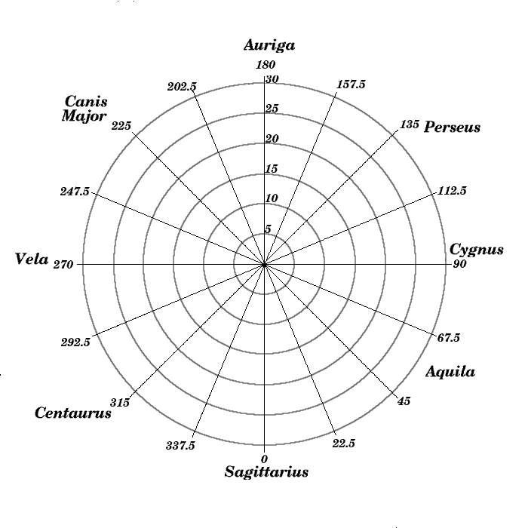](http://www.astro.washington.edu/courses/labs/clearinghouse/homeworks/images/galplot.jpg)**