**Where is the Center of the Milky Way?**

(From Anna Larson, U. Washington)

Globular star clusters are bright, and can be seen for a long distance. Their distances can be estimated accurately from their main sequence turnoffs, as well as by measuring the periods of variable stars that belong to each cluster. In the table below are listed a few dozen Galactic globular clusters with their distances (in kiloparsecs) and their directions in galactic longitude. Most of the globular clusters fall above or below the plane of the Milky Way. They have been projected down to the plane, with their distances foreshortened accordingly.

* A “’kiloparsec” is 1000 parsecs. A parsec is 3.26 light years.
* Galactic longitude is like longitude on Earth, but measured along the plane of the Milky Way. The zero of Galactic longitude is toward the Galactic Center.

Plot each cluster on the diagram on page 2, at its correct projected distance and direction from the Sun, which is located at the center of the plot.

|  |  |  |  |  |  |  |  |  |  |  |  |  |  |  |
| --- | --- | --- | --- | --- | --- | --- | --- | --- | --- | --- | --- | --- | --- | --- |
| **NGC #** | **Gal.  Long.** | **Projected  Distance  (kpc)** |  | **NGC #** | **Gal.  Long.** | **Projected  Distance  (kpc)** |  | **NGC #** | **Gal.  Long.** | **Projected  Distance  (kpc)** |  | **NGC #** | **Gal.  Long.** | **Projected  Distance  (kpc)** |
| 104 | 306 | 3.5 |  | 6273 | 357 | 7 |  | 288 | 147 | 0.3 |  | 6284 | 358 | 16.1 |
| 362 | 302 | 6.6 |  | 6287 | 0 | 16.6 |  | 1904 | 228 | 14.4 |  | 6293 | 357 | 9.7 |
| 2808 | 283 | 8.9 |  | 6333 | 5 | 12.6 |  | Pal 4 | 202 | 30.9 |  | 6341 | 68 | 6.5 |
| 4147 | 251 | 4.2 |  | 6356 | 7 | 18.8 |  | 4590 | 299 | 11.2 |  | 6366 | 18 | 16.7 |
| 5024 | 333 | 3.4 |  | 6397 | 339 | 2.8 |  | 5053 | 335 | 3.1 |  | 6402 | 21 | 14.1 |
| 5139 | 309 | 5 |  | 6535 | 27 | 15.3 |  | 5272 | 42 | 2.2 |  | 6656 | 9 | 3 |
| 5634 | 342 | 17.6 |  | 6712 | 27 | 5.7 |  | 5694 | 331 | 27.4 |  | 6717 | 13 | 14.4 |
| Pal 5 | 1 | 24.8 |  | 6723 | 0 | 7 |  | 5897 | 343 | 12.6 |  | 6752 | 337 | 4.8 |
| 5904 | 4 | 5.5 |  | 6760 | 36 | 8.4 |  | 6093 | 353 | 11.9 |  | 6779 | 62 | 10.4 |
| 6121 | 351 | 4.1 |  | Pal 10 | 53 | 8.3 |  | 6541 | 349 | 3.9 |  | 6809 | 9 | 5.5 |
| O 1276 | 22 | 25 |  | Pal 11 | 32 | 27.2 |  | 6626 | 7 | 4.8 |  | 6838 | 56 | 2.6 |
| 6638 | 8 | 15.1 |  | 6864 | 20 | 31.5 |  | 6144 | 352 | 16.3 |  | 6934 | 52 | 17.3 |
| 6171 | 3 | 15.7 |  | 6981 | 35 | 17.7 |  | 6205 | 59 | 4.8 |  | 7078 | 65 | 9.4 |
| 6218 | 15 | 6.7 |  | 7089 | 54 | 9.9 |  | 6229 | 73 | 18.9 |  | 7099 | 27 | 9.1 |
| 6235 | 359 | 18.9 |  | Pal 12 | 31 | 25.4 |  | 6254 | 15 | 5.7 |  | 7492 | 53 | 15.8 |
| 6266 | 353 | 11.6 |  |  |  |  |  |  |  |  |  |  |  |  |

[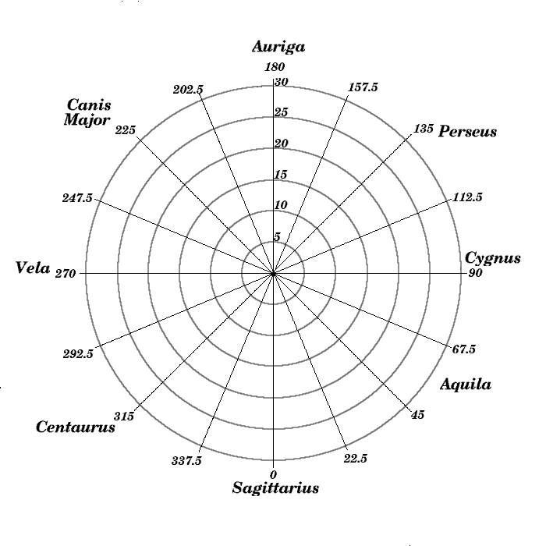](http://www.astro.washington.edu/courses/labs/clearinghouse/homeworks/images/galplot.jpg)Mark a clear “X” at the location of the Galactic Center. Estimate the distance to the Galactic Center and the constellation toward which the center is found.

Distance _____________________________ Constellation ___________________________

Our knowledge of globular clusters on the far side of the disk of the Milky Way is incomplete. How might this affect a determination of the location of the Galactic Center based on the globular clusters?