Galactic Chemical Evolution

Below is a plot of the relative abundance of elements in the Sun and nearby stars. The plot is logarithmic so that each unit on the y-axis is a factor of 10. For example, the Sun contains 10⁻¹⁰ atoms of lithium for each atom of hydrogen, and 10⁻⁵ atoms of iron for each atom of hydrogen.

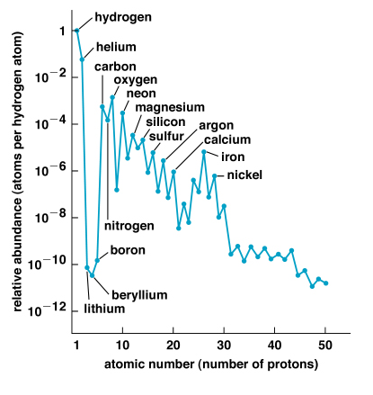

a. How would the distribution of elements be different if the universe contained no stars?

b. How would the distribution of element abundances be different if the universe contained stars less massive than the Sun?

c. How would the distribution of element abundances be different if the universe contained only massive stars?

