Elements Produced in Supernova Explosions

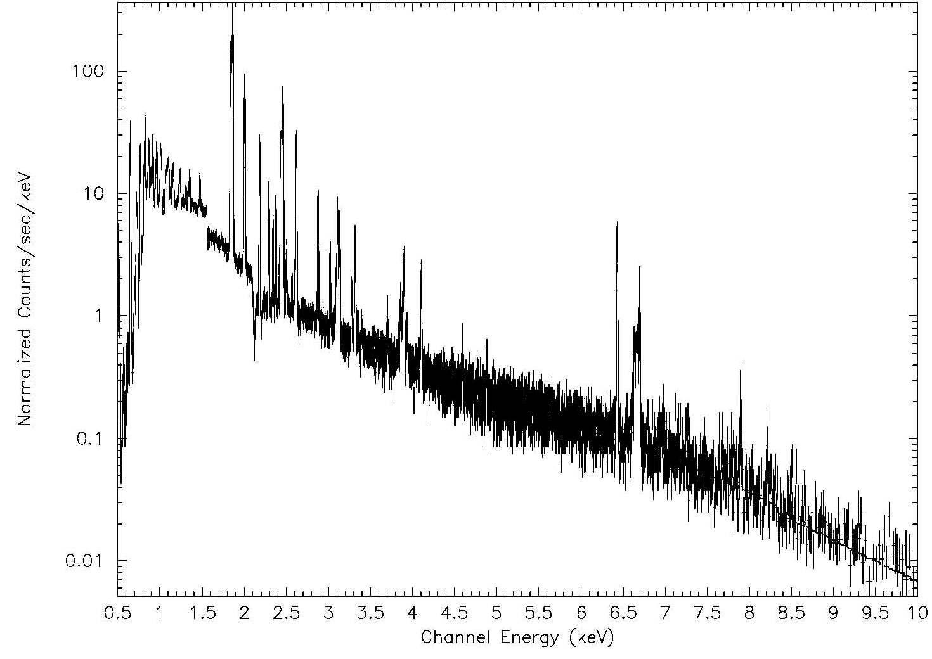

The image above is an x-ray spectrum of the Tycho supernova remnant showing the intensity of x-ray emission from the shocked gas in the expanding nebula. Tycho is a Type Ia supernova, from an exploding carbon-oxygen white dwarf. The x-axis shows the energy of the x-rays in units of kilo-electron Volts. The sharp peaks are strong emission lines due to various elements produced in the intense stellar explosion. These emission lines are used to measure the abundances of elements produced in supernovae.

Element | Energy (eV) |  | Element | Energy (eV)
Oxygen (O) | 0.547 |  | Sulfur (S) | 2.461
Oxygen (O) | 0654 |  | Sulfur (S) | 2.632
Neon (Ne) | 0.922 |  | Argon (Ar) | 3.140
Neon (Ne) | 1.022 |  | Argon (Ar) | 3.323
Magnesium (Mg) | 1.352 |  | Calcium (Ca) | 3.903
Magnesium (Mg) | 1.471 |  | Calcium (Ca) | 4.108
Silicon (Si) | 1.865 |  | Iron (Fe) | 6.701
Silicon (Si) | 2.006 |  | Iron (Fe) | 6.973

Identify lines of each element in the spectrum above with the chemical for the element.

Which element shows the strongest lines? ________________________________________

