The Jewels of the Night

Work with a partner on this task. We will use a color image of the Jewelbox star cluster, and a “star gauge” to measure brightness and color. The goal is to construct a Hertzsprung-Russell diagram of the Jewelbox cluster to estimate the age of the cluster

Examine the print of the Jewelbox Cluster provided in class. Can you tell the approximate boundary of the cluster in space? Outline where you think the boundaries of the cluster are with a marker. Use a ruler to draw a square about 5 cm square on a side around the center of the cluster.

a. What property of the stars in the image gives you information about the brightness of the star?

b. What property of the stars in the images gives you information about the temperature of the star?

Use the star gauge to measure the brightness and temperature of each star in square you have drawn. Be systematic - start in one corner and mark off each star you measure as you plot it in the graph.

c. When you have plotted all the stars in the 5 cm box, draw a line on your graph indicating the location of the main sequence of the Jewelbox cluster. Label the line "main sequence."

Stars in front of or behind the Jewelbox which are not part of the cluster may also appear in the image.

d. Circle any stars in your HR diagram that might be "field" stars and not part of the Jewelbox cluster.

e. Estimate the age of the Jewelbox cluster by comparing your HR diagram with the sample diagrams shown below the graph. Age: ________________________

f. Describe the reason that led you to your estimate of the age of the Jewelbox.

g. If our Sun were a member of the Jewelbox cluster, where would it fall in the graph? Plot and label the Sun in the graph.
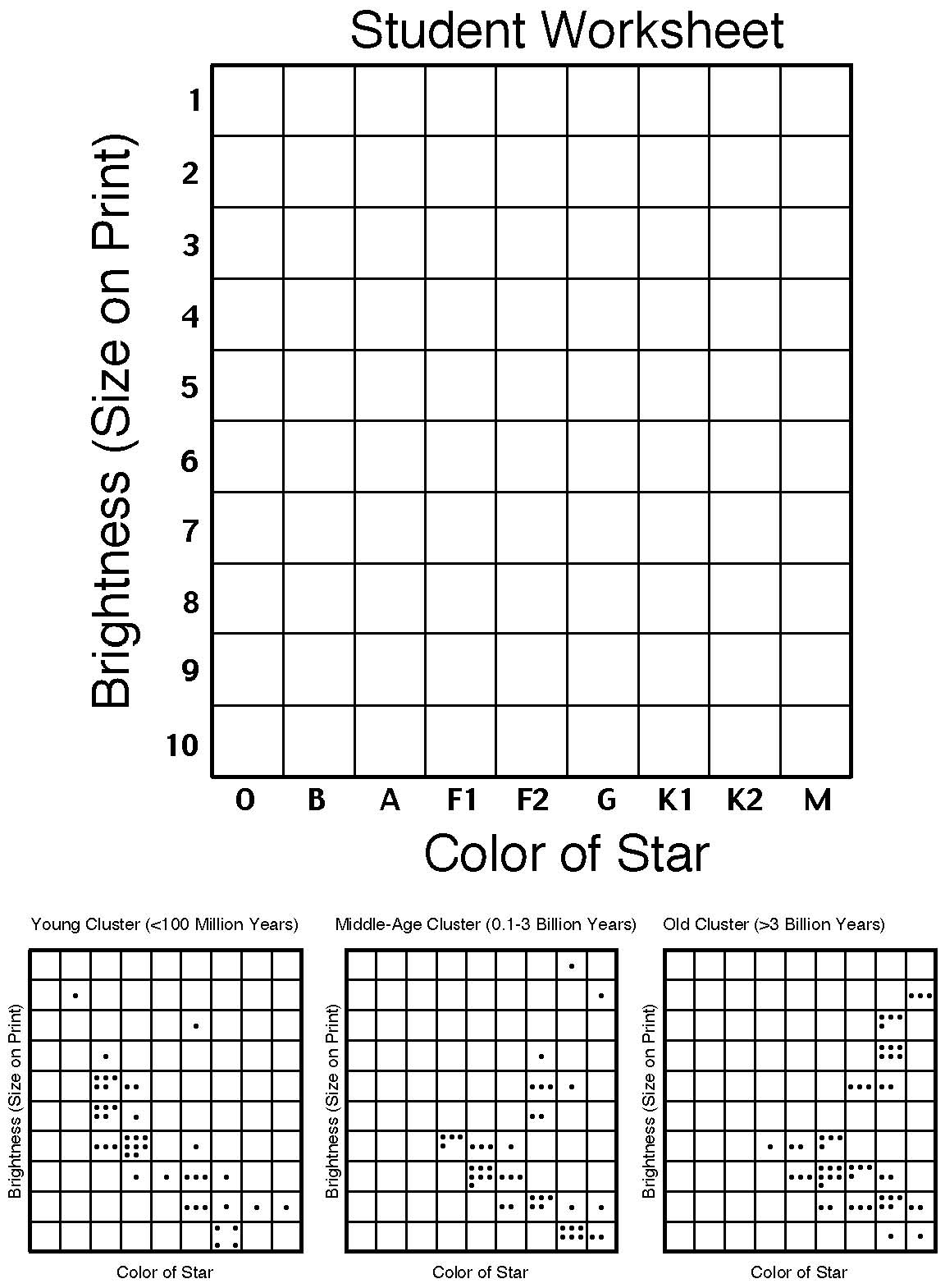

From the NOAO website

