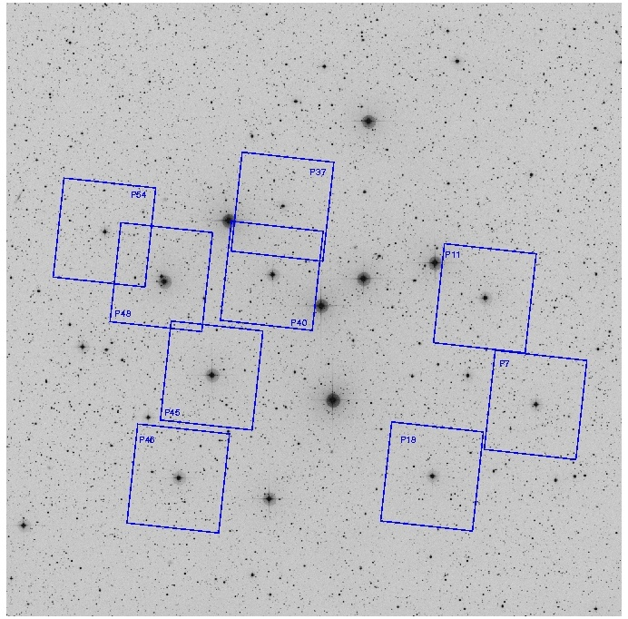
Finding Dusty Disks with Spitzer

In the image of the star cluster IC 4664 shown at right, the small rectangles mark regions imaged with an infrared camera on the Spitzer Space Telescope. The bright stars in the centers of each rectangle are the targets of this investigation.

The brightness of stars in IC 4665 measured at several wavelengths of light are included in the table below. The stars are identified by number.

The Spitzer observations for this activity were obtained at a wavelength of 24,000 nm (24 μm or 0.024 mm), in the mid-infrared range of the spectrum.

The brightness of a star in each waveband is measured in units of milli-Jansky. A Jansky is 10⁻²⁶ watts per square meter in that waveband (and a milli-Jansky is 10⁻²⁹ watts per square meter). A special unit for such a small amount of energy is needed to describe the brightness of astronomical sources because, being at very large distances, the stars appear to be extremely faint.

The graph labeled "Flux Densities for IC 4665" displays the expected brightness of IC 4665 stars of different temperatures at the distance of the cluster. The thermal curves from 5,000 to 12,000 K (degrees Kelvin) have been computed using basic physical constants, and estimates of the radii of stars at each temperature. The brightness of stars is a function of temperature (hotter stars are brighter at each wavelength), radius (bigger stars are brighter, and hotter stars have larger radii than cooler stars), and distance (through the inverse square law).

- Work in a group of 4 students and each select ONE star to plot on the graph.

- Plot the brightness of your star vs. wavelength.

- Estimate the temperature of your star by comparing it to the thermal spectra. Does your star’s brightness vs. wavelength curve display a similar shape to the thermal curves plotted in the figure?

Star Number: ____________________________________________

Temperature: ____________________________________________

Brightness Measurements in mJy for IC 4665 Stars
 | Wavelength (nanometers)
Star ID | B = 440 nm (blue) | V = 550 nm (yellow) | I = 970 nm  (near infrared) | J = 1235 nm  (infrared) | H = 1662 nm  (infrared ) | K = 2159 nm  (infrared)
Prosser 7 | 586 | 675 | 551 | 517 | 364 | 246
Prosser 11 | 839 | 882 | 615 | 571 | 385 | 252
Prosser 18 | 780 | 890 | 693 | 642 | 442 | 299
Prosser 37 | 217 | 257 | 207 | 189 | 136 | 89.9
Prosser 40 |  | 547 |  |  | 272 | 211
Prosser 45 | 1920 | 1970 |  | 1110 | 770 | 478
Prosser 46 | 1060 | 1080 | 732 | 622 | 387 | 274
Prosser 48 | 256 | 303 | 236 | 234 | 160 | 108
Prosser 54 | 398 | 438 | 332 | 294 | 203 | 143

Now extend your star’s thermal curve to longer wavelength. Its curve should be parallel to the other curves.

In the table below, are the measurements of the brightness of IC 4665 stars in the mid-infrared, at 24 microns (24,000 nanometers). Add your star’s 24-micron brightness to the graph.

Measured Brightness
for IC 4665 Stars at 24000 nm
Star ID | Brightness (mJy)
Prosser 7 | 1.95
Prosser 11 | 2.48
Prosser 18 | 2.63
Prosser 37 | 5.51
Prosser 40 | 4.43
Prosser 45 | 4.22
Prosser 46 | 11.06
Prosser 48 | 1.10
Prosser 54 | 1.75
Does the 24 micron brightness fall on the same thermal curve? Or is your star brighter than would be expected from the thermal curve?

Consult with other students - Which stars are extra-bright at 24 microns?

The extra brightness at 24 microns is evidence for cooler, dusty material surrounding the stars. The dust radiates most of its energy at longer wavelengths because it is cool, and it is bright compared to the star in the infrared because it is much larger than the star.
