Viewing Proplyds with Hubble
Hubble can detect protostellar or protoplanetary disks (“proplyds”) surrounding newly forming stars because the disks are illuminated by nearby hot stars in the Orion Nebula or they are seen in silhouette against the bright nebula behind them. The outer rims of the proplyd disks contain at least several times the mass of Earth. The disks are tens of billions of miles across, or several times the diameter of our solar system. Find and circle possible proplyds in the image below. Orion is at a distance of 1500 LY, and a diagonal across the image corresponds to about 1.6 light years.
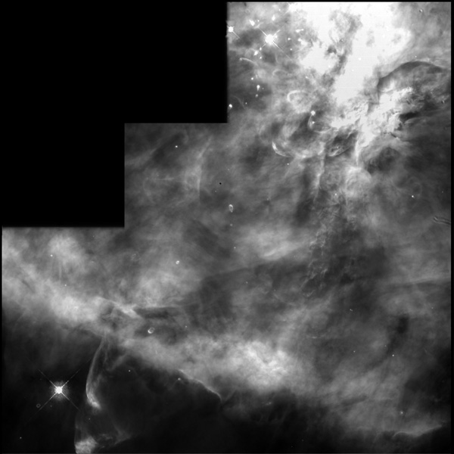
How many proplyds can you find? _____________________________________
What makes a proplyd different in appearance from a star?
How does the density of new stars in Orion compare to the density of stars near the Sun?

