The 30 Doradus Star Forming Region
Examine the Hubble lithograph of the 30 Doradus star forming region (or the digital image at http://hubblesite.org/newscenter/archive/releases/2012/01/image/a/) and read the descriptions on the back (or on the website). The region covers a region roughly 650 light years across. Red color indicates regions of hot hydrogen gas, while the bluish color is due to emission from hot, ionized oxygen. Several regions are marked in the grayscale reproduction below. Examine each region on the color lithograph, and briefly describe the object(s) inside. See if you can identify what they are.
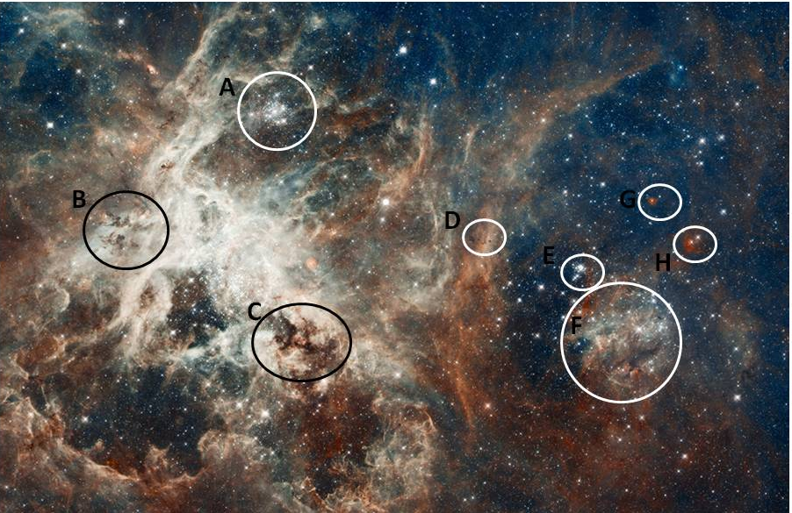
A.

B.

C.

D.
E.

F.

G.

H.

