**Motion Due to Gravity:** Although gravity is the weakest of the known forces, it dominates the Universe on large scales. The sub-atomic “strong” and “weak” forces work only over very small distances, and the electromagnetic force is weak because most mass in the Universe is electrically neutral. Understanding gravity is essential to understanding the Universe.

In the exploration, use the NAAP *Planetary Orbit Simulator* available from the University of Nebraska Lincoln at: <http://astro.unl.edu/naap/pos/animations/>.

**Part 4: Gravity and Orbits**

* Use the “clear optional features” button to remove other features
* Click on the Newtonian features tab.

1. Select the orbit for Mercury from the presets. What are the minimum and maximum speeds it attains through its orbit?
2. Review the orbital speeds for the remaining planets and dwarf planets. How does a planet’s orbital speed depend on its semi-major axis? Which planet has the highest average speed, and which has the slowest speed?
3. Click both “show vector” boxes to show both the velocity and the acceleration vectors of the planet. Observe the direction and length of the arrows. The lengths of the arrows are proportional to the speed of the planet and the gravitational force from the sun. The acceleration vector always points toward what object in the simulator? Why?
4. Create an ellipse with a = 5 AU and e = 0.5. For each marked location on the plot below a) draw the direction of the velocity vector and the acceleration vector, b) indicate whether the velocity is increasing or decreasing at the point in the orbit (by circling the appropriate arrow) and c) estimate the angle θ between the velocity and acceleration vectors. Note that one is already completed for you.

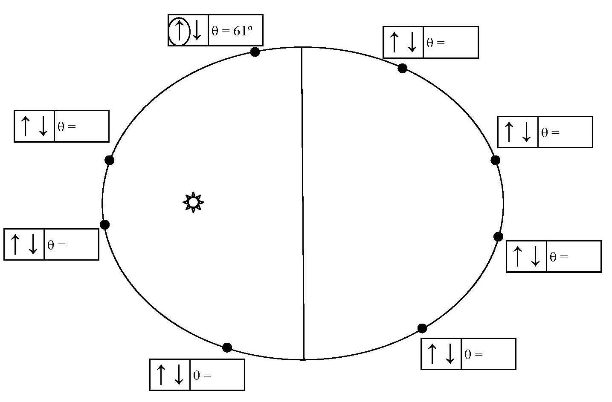

=60°