**Estimating Temperature**

Wien’s Law: Wavelength(max) = 2,900,000 / Temperature

Wavelengths are measured in nanometers, and temperatures in degrees Kelvin.

Using the infrared camera or a thermometer, measure the temperatures of materials available in the room (ice, walls, water, hot water, skin, incandescent light bulb.

Using Wien’s Law, determine the wavelength at which each material emits the most thermal radiation.

The Sun is the brightest in green light, about 500 nanometers. What is its temperature?

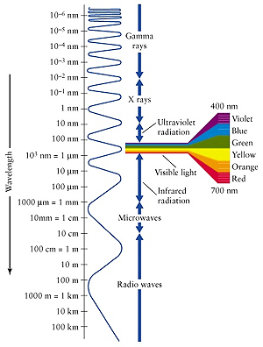

|  |  |  |
| --- | --- | --- |
| **Material** | **Temperature (K)** | **Peak Wavelength (nm)** |
| **Ice** |  |  |
| **Walls** |  |  |
| **Skin** |  |  |
| **Hot Water** |  |  |
| **Light Bulb** |  |  |
|  |  |  |
| **The Sun** |  | **501 nm** |

A microwave telescope “sees” microwave light coming from all directions in the sky. This microwave signal is fairly strong, accounting for about 1% of the “noise” detected by a television antenna set “off channel.” A plot of the brightness of the microwave emission vs. wavelength is shown below. From Wien’s law and the wavelength at which the microwave emission is brightest, estimate the temperature of the source of the microwave emission.

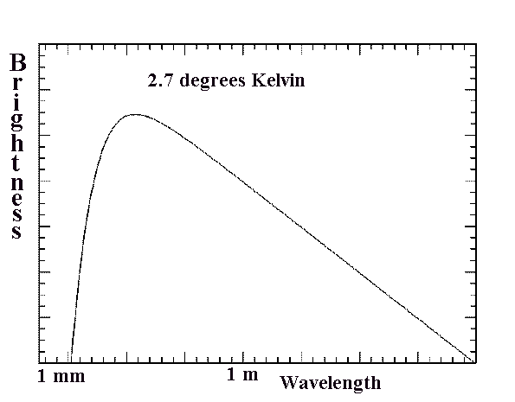

The brightness of the microwave radiation in a small patch of sky is shown below in pseudocolor. What is the range of temperature observed in the microwave radiation? How much would this difference in temperature shift the wavelength of the peak of the spectrum shown above?



