Analyzing Infrared Images

Examine the three pairs of optical and infrared images of the Old Faithful geyser in Yellowstone National Park (Old Faithful is the most frequently erupting large geyser in the park). A geyser is a hot spring which erupts periodically. These eruptions are caused by the buildup of hot water and steam trapped by constrictions in the "plumbing system" of a hot spring. When enough pressure builds up the geyser erupts. The three image pairs are a time sequence from the beginning to the end of the geyser’s eruption.

The infrared images are shown in “pseudocolor” since our eyes cannot see infrared light. Color corresponds to temperature with the hottest parts of the image shown as white light and the coolest parts shown as black.

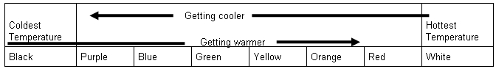

- Which regions of the image are the coolest?

- Which regions are the hottest?

- Do the infrared images give you information that you cannot get from the visible light images?

- Describe the difference between pseudo color and true color. In what circumstances would pseudo color be useful?

- What would astronomers learn from observations of astronomical objects in infrared light, compared to observations in visible light?

Visible Light Images Infrared Images
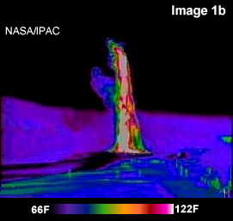
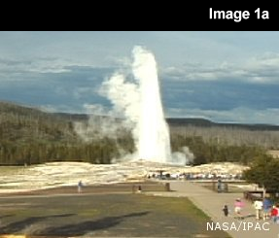

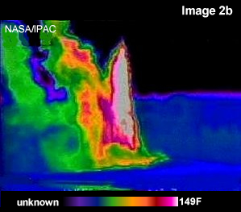
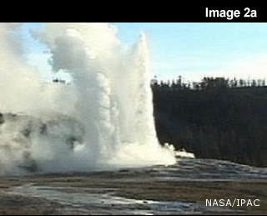

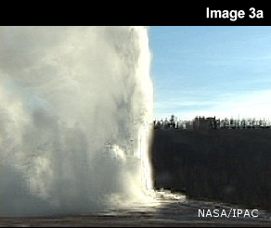
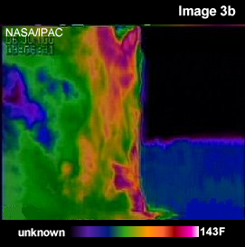

The Invisible Yellowstone National Park© Cool Cosmos at Spitzer Science Center http://coolcosmos.ipac.caltech.edu

