**Basic Assumptions about the Universe**

Discuss with a partner what assumptions might be reasonable for scientists to make about the Universe. List three or four. For each describe why this is a reasonable assumption for our universe, and what the assumptions might imply for the origin, evolution, or structure of our universe.

a)

b)

c)

d)

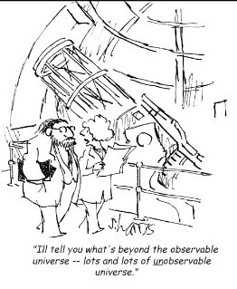The boxes below are meant to represent small portions of very large two-dimensional universes. . An astronomer, located on a galaxy somewhere in the box, is trying to understand the structure and important properties of her/his universe to make predictions about what s/he/it would see for different models, depending on whether the universe is homogeneous and/or isototropic..

For each universe, sketch in a distribution of galaxies that would represent the caption given.

The universe appears isotropic but not homogeneous to the observer.

The universe appears homogeneous but not isotropic to the observer.

The universe appears isotropic to the observer.

The universe appears homogeneous to the observer.

