**Our Place in the Milky Way Galaxy**

On the next page is a chart for mapping the Milky Way Galaxy. The chart is centered at the position of the Sun, with Galactic longitude around the circumference, and concentric circles centered on the Sun’s position at 5000, 10000, 15000, 20000, 25000, and 30000 light years in distance

The first chart below gives the Galactic longitudes and distances of several well-known objects. The second chart provides longitudes and distances for tracing out the Galaxy’s spiral arms. Plot each of the objects on the Galactic chart, and trace out the locations of the spiral arms.

|  |  |  |
| --- | --- | --- |
|  | Galactic Longitude | Distance |
| The Sun | Not defined | 8 light minutes |
| Orion Nebula | 209° | 1300 LY |
| Crab Nebula | 185° | 6500 LY |
| Carina Nebula | 288° | 8800LY |
| Ring Nebula | 63° | 1500 LY |
| Saturn Nebula | 38° | 4000 Ly |
| Eagle Nebula | 17° | 5700 LY |
| Galactic Center | 0° | 26,000 LY |

|  |  |  |  |  |  |  |  |  |  |
| --- | --- | --- | --- | --- | --- | --- | --- | --- | --- |
| Gal.  Long | Perseus Arm | Local Spur |  | Gal.  Long | Sagittarius Arm |  | Gal.  Long | Scutum-Crux Arm | Norma Arm |
| 270° | 30000 | 8000 |  | 292.5° | 30000 |  | 310° | 30000 |  |
| 247.5° | 20000 | 2500 |  | 280° | 18000 |  | 315° | 19000 |  |
| 225° | 13000 | 2000 |  | 292.5° | 8000 |  | 330° | 12000 | 30000 |
| 180° | 9000 | 1000 |  | 315° | 6000 |  | 337.5° | 11000 | 23000 |
| 135° | 10000 | 1000 |  | 0° | 5000 |  | 0° | 11000 | 18000 |
| 90° | 17000 | 4000 |  | 45° | 12000 |  | 22.5° | 15000 | 25000 |
| 67.5° | 25000 |  |  | 50° | 23000 |  | 30° | 25000 |  |
|  |  |  |  | 45° | 30000 |  | 25° | 30000 |  |

**[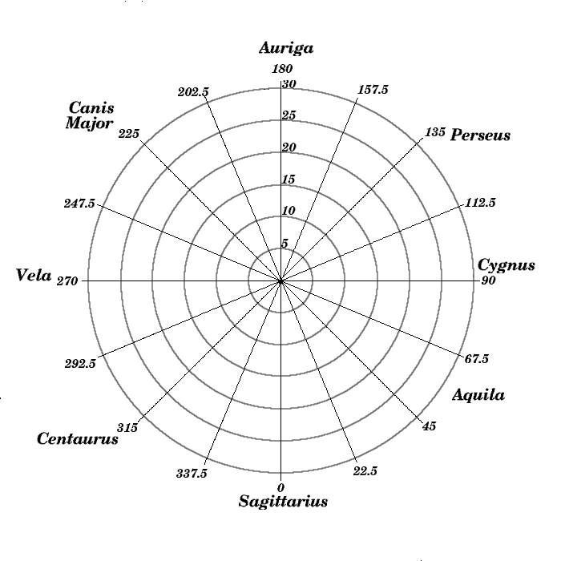](http://www.astro.washington.edu/courses/labs/clearinghouse/homeworks/images/galplot.jpg)**