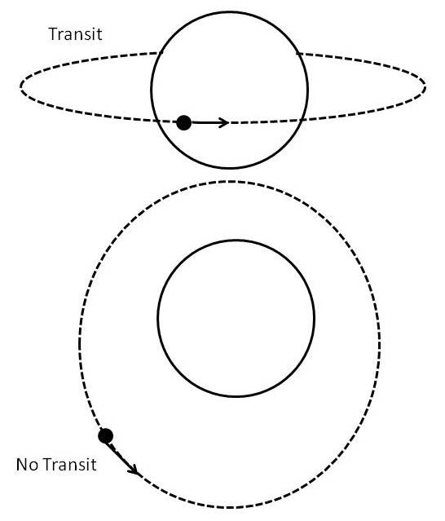
Transiting Planets

A second method to find planets is to detect their passage across the disk of their host star (like the transit of Venus across the Sun in June, 2012). This occurs when we observe the star and planet in the plane of the planet’s orbit. When a planet crosses between us and the star, it blocks a small fraction of the star’s light, so the star appears dimmer. In most cases, the orbital plane is tipped so that we cannot see a transit, but in a few cases, we can see transits.

- If a planet transits its host star, we know the inclination of the orbital plane
- From the inclination of the orbital plane, we can calculate the true mass of the planet.
- From the depth of the transit (the fraction of the star’s light that is blocked), we can calculate the radius of the planet.
- From the mass and radius of the planet, we can calculate its density.
- From the density, we can determine if it is a rocky planet, an ice planet, or a gas planet.
- Knowing the temperature the host star and the semi-major axis of the planet’s orbit, we can calculate the temperature of the planet to determine if it will have liquid water on its surface, and if it could sustain life as we know it.

At http://www.bridgewater.edu/~rbowman/ISAW/Transit-1.html begin the "Finding Exoplanet" simulation. Run the simulator first for the default star (#1). Then go back and run the simulation again for two more stars for which an orbital period can be determined from transits. Fill out the table below for star #1 and for your two additional stars.

Star Number |  |  |  | Star #1
Period (in years)
Semi-Major Axis (AU)
Is the planet in the star’s habitable zone?
Planet Temp (K)
Planet Radius (in Earth radii)
Mass, model 1, in Earth masses
Mass, model 2, in Earth masses
Probability of detection

