Big Bang Nucleosynthesis
The universe is roughly 1/4 helium and 3/4 hydrogen by mass, but very little of this helium was made in stars. Early in the Big Bang the Universe was hot and dense (like the core of a star) and protons could fuse together to make helium. The fact that the Universe is 1/4 helium is evidence for the existence of the Big Bang and a hot early Universe.
In the very early Universe, (before 0.01 seconds), the temperature was too high for even protons and neutrons to exist, much less the nuclei of atoms, which require protons and neutrons to bond together. Once the Universe expanded and cooled to 100 billion degrees, neutrons and protons could persist. Not only that, but they could switch back and forth:
neutron + neutrino -> proton + electron
neutron + positron -> proton + anti-neutrino
neutron -> proton + neutrino + electron
The total number of particles stays the same but the fraction which are neutrons depends on the temperature, (and nothing else). Another way to say this is that the neutrons and protons numbers are in thermal equilibrium. To stay in thermal equilibrium all of the reactions above need to be occurring frequently.
Neutrons require more energy to make because they are heavier than protons (E = m c²). As the temperature in the early universe continues to drop, less and less energy is available, and the reactions begin to favor protons. At temperatures under 3 billion Kelvin, very few neutrons are present, and new ones are not created. The neutrons created at higher temperature quickly decay to become protons. By the time the universe cools to a temperature of 1 billion degrees, very free few neutrons remain.

If nuclei did form, high energy radiation (gamma rays) knocked them apart.
Temperature | Equilibrium Neutron Fraction  neutrons/(neutrons+protons) | Equilibrium Reaction Speed
100,000,000,000 K | 50/100 | Fast
30,000,000,000 K | 37/100 | Slow
10,000,000,000 K | 18/100 | Stopped
3,000,000,000 K | 1/100 | Stopped
1,700,000,000 K | 0.01/100 | Stopped
1,200,000,000 K | 0.0004/100 | Stopped
1,000,000,000 K | 0.00003/100 | Stopped
900,000,000 K | 0.000006/100 | Stopped

In the boxes below, there are 100 particles (protons or neutrons) in a box at various times. Using the equilibrium fractions given in the table, indicate how many are neutrons at 0.1 seconds and 1 second by marking the circles. The box for 0.01 seconds is already marked. Below 10,000,000,000 K, the reaction rate is so slow that the fraction of neutrons freezes.

How many neutrons are left after 1 second? __________________________________________
Once the equilibrium reactions have stopped then neutrons simply decay:
neutron -> proton + neutrino + electron
The decay has a half life of 600 seconds. In 600 seconds, a neutron is as likely to turn into a proton as it is to stay a neutron. This can be simulated by tossing a coin. If it lands heads up, the neutron has turned into a proton. The chance of decaying in 50 seconds is much less, one in 16. The neutron will turn into a proton if four coins land heads up.
Take the neutrons present at 1 second and for version 2 of the Big Bang determine if each neutron makes it to 50 seconds and mark it in if it does. Take the neutrons present at 50 seconds and repeat the procedure again for 50 seconds later (100 seconds). Evolve your set of neutrons to 200 seconds this way. You should have a reasonable number of neutrons left at 200 seconds.
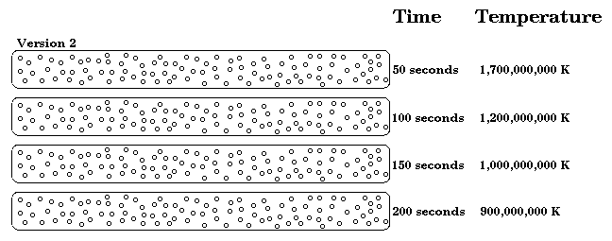
Once the Universe is cool enough, deuterium nucleus (a nucleus containing one proton and one neutron) can form, a necessary step in forming helium. All deuterium is converted quickly into helium. In the boxes for 150 seconds and 200 seconds, draw circles around groups of two neutrons and two protons to form helium nuclei. If you have any left over neutrons draw a circle around it and one proton. This is a deuterium nucleus. Once neutrons are inside a nucleus they stop decaying. (A small amount of lithium is also produced during Big Bang nucleosynthesis when nuclei combine.)
In the table below, enter the number of protons, helium nuclei, and deuterium nuclei that could be formed at ages of 150 and 200 seconds.
At each age, enter the fraction of helium by number, that is, the fraction
# of helium nuclei / (# helium + # deuterium + # protons)
Assume each proton and neutron weighs the same. What fraction of the mass is now in the form of helium?
Time | Number of Protons | Number of Heliums | Number of Deuteriums | Total Number of Nuclei | Percent Helium | Percent Deuterium
150 s
200 s
Theoreticians predict that helium will comprise about 10% of nuclei and deuterium will comprise about 0.01% of nuclei.
How do your results compare to theoretical predictions?

Developed at the University of Washington

