The Cosmic Microwave Background Radiation

The CMB radiation arises from an early phase in the history of the universe, just at the point where the universe is cool enough for protons and electrons to combine to form hydrogen atoms. Before that, hot protons and electrons were moving too fast. The loose electrons scattered light, so that light could travel only a short distance before being scattered to a new direction, and the universe appeared opaque. Once atoms formed, light could travel freely, and the universe became transparent. The light we see now as the CMB radiation comes to us directly from that time in the history of the universe when atoms first formed. This period of time in the history of the universe is known as “recombination.”

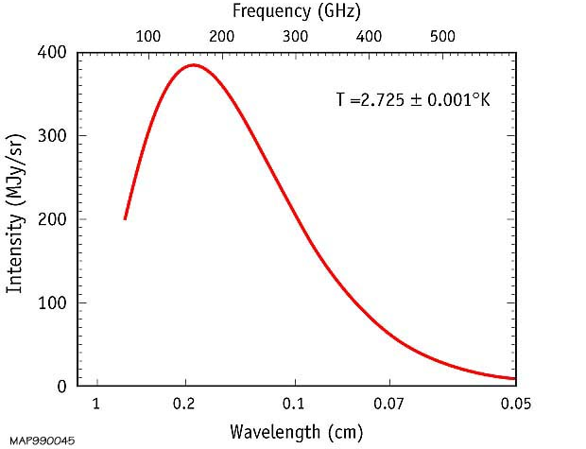
NASA’s Cosmic Background Explorer satellite measured the spectrum of the CMB radiation shown at right (the CMB radiation is in the microwave part of the electromagnetic spectrum). The intensity of the CMB radiation is highest at a wavelength of 1.06 millimeters.

a) In the box below, draw a wave with a wavelength of 1.06 mm.

b) Use Wien’s law to determine the temperature of the CMB radiation we observe today. Recall that Wien’s law relates the wavelength of peak brightness to temperature:

$$temperature=2.9/wavelength$$

Temperature of the observed CMB radiation: __________________________________

c) Microwave radiation corresponding to this temperature permeates the universe today. Nothing in the universe today is colder than this temperature. Explain why.

d) Protons and electrons combine to form hydrogen atoms at a temperature of about 4000K. At hotter temperatures, they are loose subatomic particles and at lower temperatures, they stick together as atoms. Use Wien’s law to predict the wavelength of greatest intensity at a temperature of 4000K.

$$wavelength=2.9/temperature$$

Wavelength of the radiation at T=4000 K __________________________________

What color would this radiation appear to our eyes? _________________________

e) The CMB radiation has been stretched by the expansion of space since it originated at the time of recombination. By approximately what factor has the radiation been stretched since recombination?

$stretch factor= \frac{wavelength today}{wavelength then}$ = ____________________________________

The “stretch factor” is the same as the redshift z from which the radiation arises.

The spectrum of the CMB radiation has exactly the shape expected from a “black body” thermal radiator with a single temperature. Suppose the CMBR did not come from the nearly uniform, evenly distributed, hot, 4000 K gas at the end of the Era of Nuclei, but rather from many individual stars and galaxies that first formed in the early Universe. How would the spectrum of the CMBR differ from the spectrum we observe?

