Galaxy Voids

The image below is a map of the distribution of galaxies out to a redshift of z=0.2, or a distance of about 2 billion light years (or about 600 million parsecs). Each dot in the image represents a galaxy observed with the Anglo-Australian telescope 2dF Galaxy Redshift Survey, which measured redshifts (velocities) for more than 200,000 galaxies. Measuring the redshift allowed the astronomers to determine the distance to each galaxy. The galaxies are plotted in the image below as a slice through the sky, revealing how galaxies are distributed in space. The survey is more or less complete out to a distance of about 1 billion light years (600 million parsecs), but is incomplete at larger distances, so the density of galaxies appears to taper off at greater distance. This is an artifact resulting from the fact that galaxies get fainter at greater distances, so that redshifts can only be measured for the brightest galaxies at large distances.

A. Describe how galaxies are distributed in space. Is the distribution smooth and uniform, or are galaxies clumped together? What sort of structures are present in the image?

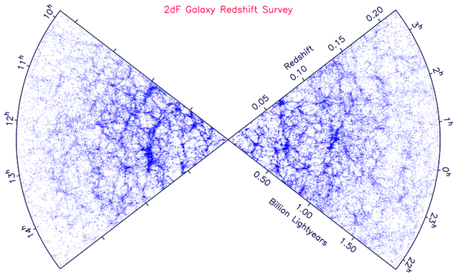
B. Mark and label 3-4 galaxy filaments in the image. What is the length of the longest filament in the image? Give your answer in light years using the scale in the image.

C. The filaments surround regions of low galaxy density, where few galaxies are found. Mark 6 voids in the image above, and indicate the diameter of each using the scale in the image.

