Large-scale structure/HDF (adapted from the University of Washington)

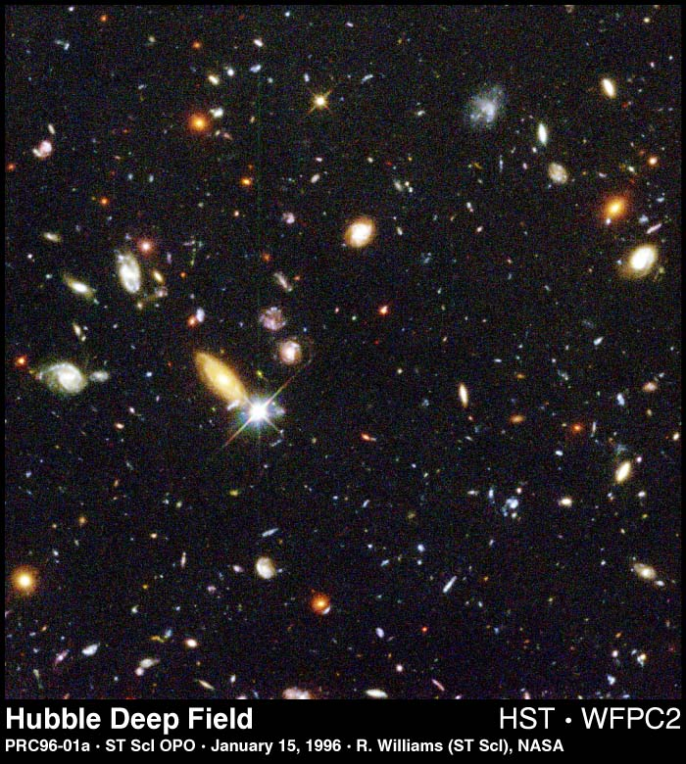
Examine the image of the Hubble Deep Field (by deep, astronomers mean dim and distant). The HDF takes us far out into space and far back in time to see the faintest objects ever detected. It reaches 30th magnitude, or about 4 billion times fainter than the naked human eye can see. The image contains thousands of galaxies of many shapes and colors. To create it, the Hubble Space Telescope exposed its electronic detectors for about 100 hours over the course of 10 days, pointed at the tiny region of space near the constellation Ursae Major.

This image covers an area about 1/100 that of the full Moon. After this image was obtained, the Earth-based, 10-meter Keck telescope was used to observe the faint blue galaxies in the image. Astronomers have concluded that the small blue shards are among the most distant objects ever seen. These objects may represent galaxies caught in the act of formation. In all, the number of galaxies in the image implies that there are hundreds of billions of galaxies in the observable universe.

Next to many of the galaxies in the HDF is each galaxy’s redshift, z, (except for a few cases, the corresponding galaxy is usually the galaxy located to the upper left of the redshift number). Notice that galaxies in the Deep Field have redshifts of 1.36, 2.80, 3.23, even 4.02

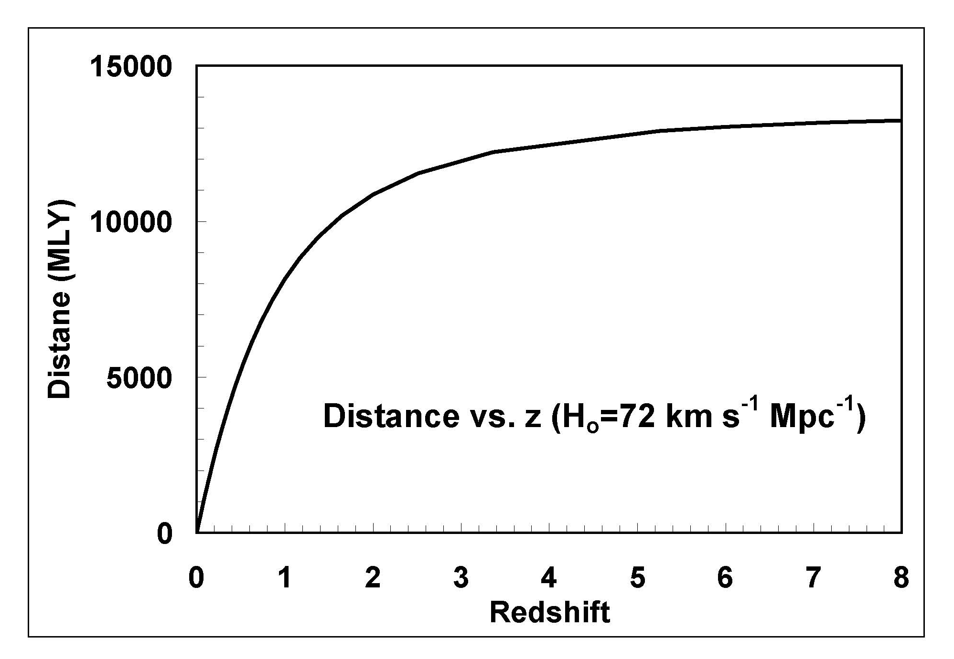
Procedure

Since the redshifts of objects are related to their distances, knowing the redshifts allows us to determine the distance to each galaxy in the Hubble Deep Field and to examine the actual distribution of galaxies in this portion of the sky.

Examine the redshifts for the galaxies in the HDF. Do we find galaxies at all redshifts in this direction in space, or are the galaxies clustered at particular redshifts (or distances)?

An easy way to examine the distribution of galaxies with distance is to construct a histogram. Count the number of galaxies in each redshift bin from z=0.0 to z=4.0. Bins of size 0.1 in redshift are a good choice.

Using the annotated image of the HDF, plot a histogram of the number of galaxies in each redshift bin. Starting at the bottom of the chart, mark an “X” for each galaxy at its appropriate redshift.
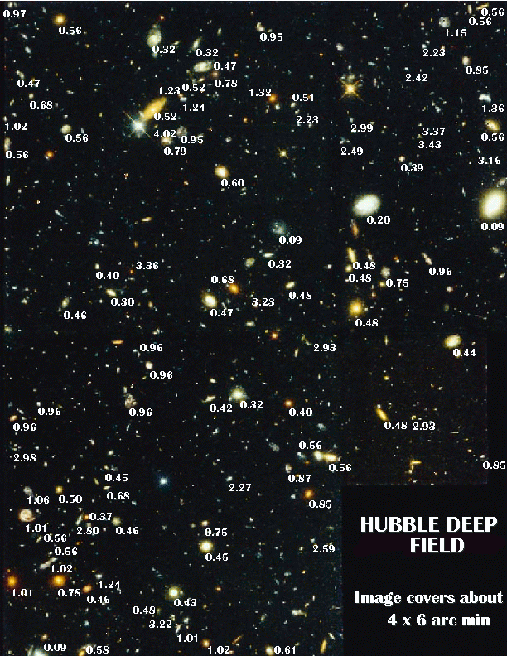
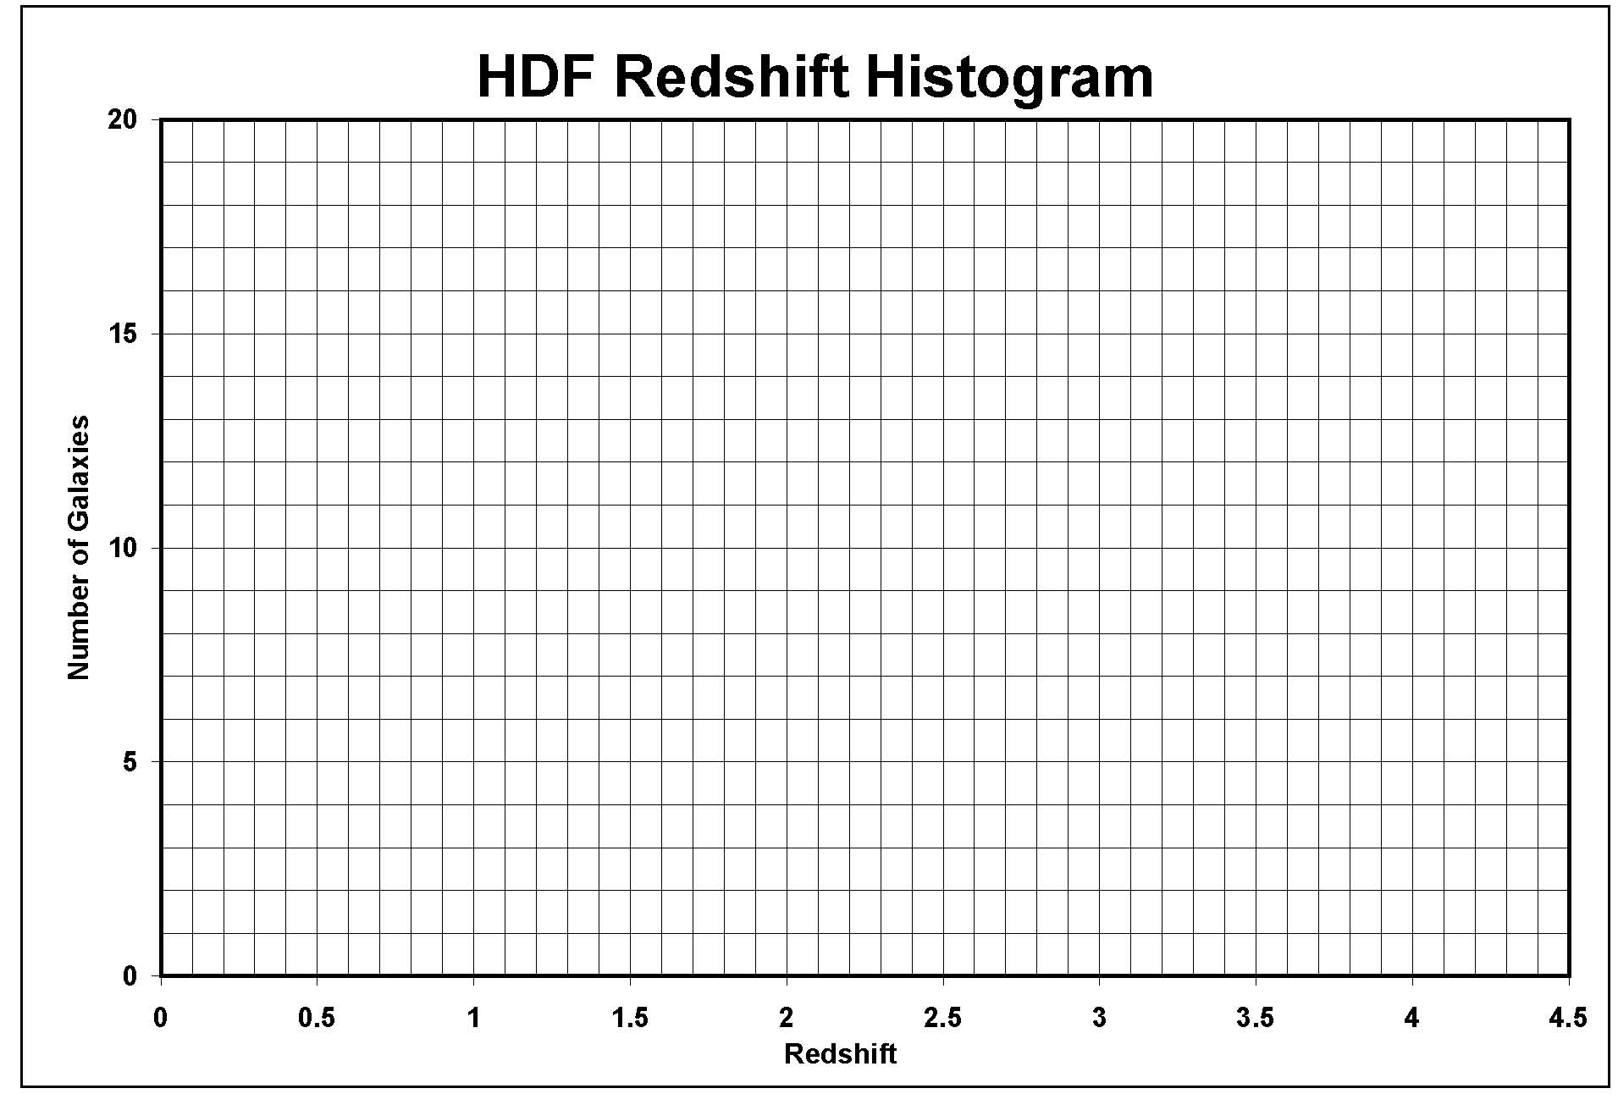
- At what redshifts do you see possible large scale structure such as clustering? (Look for redshifts where many galaxies are found.)

- Are there voids in this field? If so, at what redshifts? (Voids are regions of space or redshifts where few galaxies are found.)

- At what distances or "look back" times do the voids and regions of clustering occur? (Use the Cosmology Calculator at www.kempner.net/cosmic.php with H₀ = 67.8 km/sec/Mpc, Ω_{m}=0.308, and Ω_{Λ}= 0.692.

- This is an extremely small "pencil beam" of the Universe. Can you find a cluster of galaxies, identified as a region of the image where a number of galaxies are close together in this 2-D image, with each of those galaxies having similar cosmological redshifts. Can you find a group of galaxies that might be classified as a cluster?

