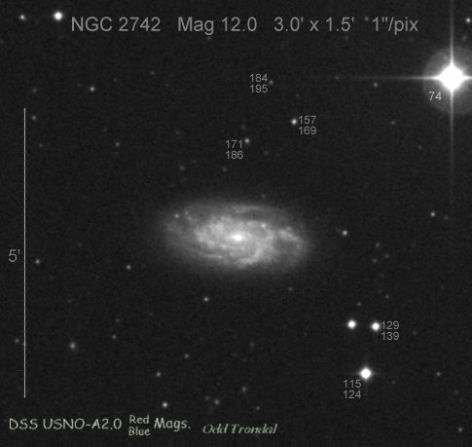**Dark Matter in NGC 2742[1]**

NGC 2742 is a spiral galaxy similar to the Milky Way, but at a distance of about 65 million light years. NGC 2742 is oriented neither face-on nor edge-on, but has an intermediate inclination. Its intermediate inclination allows us to apply two methods to measure its mass, and compare them. We can determine the inclination of the galaxy by comparing its largest and smallest diameters and assuming the galaxy would be circular if we could see it face-on.

**a. Gravitational Mass**. Below is a rotation curve for NGC 2742 (also known as UGC 4779). The graph plots the radial velocity of the galaxy as a function of distance

from the center of the galaxy.



The radial velocity of NGC 2742 (or UGC 4779) rises quickly from the center as we move out in radius, and reaches a maximum some distance out from the galactic center. The velocity rises outward because the amount of mass contained is increasing as we move outward. The speed of rotation at a given radius is proportional to the square root of the mass inside that radius and to the square root of the reciprocal of the distance from the center of the galaxy.

- At ONE of the radii given, determine the absolute value of the rotational velocity of the galaxy and enter it in the table.

- Use the values of the radius and velocity to determine the mass of the galaxy inside that radius. According to Newton's law of gravity



where G is the gravitational constant, "v" is the rotational velocity, and "M" is the mass contained inside of radius “R.” Here, we are using astronomical units. Mass is measured in solar masses, radius is measured in kiloparsecs (Kpc), and velocity is measured in km s-1. Using these units, the gravitational constant has a value of 4.31 x 10-6 Kpc km2 M☼-1 s-2.

Record your results in the “Gravitational Mass” column in the table. Your numbers should be big. This is a galaxy you're dealing with. It contains a lot of stars. Use scientific notation!

|  |  |  |  |  |  |
| --- | --- | --- | --- | --- | --- |
| **Radius (Kpc)** | **Rot. Vel. (km s-1)** | **Grav. Mass (solar masses)** | **Luminosity**  **(solar lum.)** | **Luminous Mass (solar masses)** | **Ratio   Lum/Grav Mass** |
| **2 Kpc** |  |  |  |  |  |
| **4 Kpc** |  |  |  |  |  |
| **6 Kpc** |  |  |  |  |  |
| **8 Kpc** |  |  |  |  |  |
| **10 Kpc** |  |  |  |  |  |

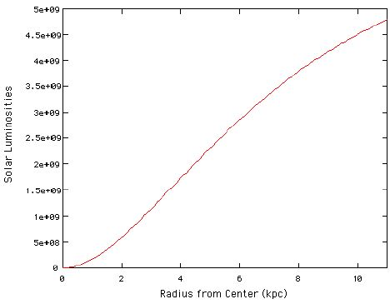

**b. The Luminous Mass -** Now that you have found the total mass of the galaxy, we will investigate how much of that mass comes from matter we can see - the stars! The next figure is a graph of how many solar luminosities of light NGC 2742 produces as a function of distance from the center of the galaxy.

At the radius you are assigned, find the value for the luminosity within that radius and record it in the table. The luminosity is given in solar luminosities.

Now that you have measured how much light is coming from NGC 2742, you can estimate the mass of the stars that produced that light. It would be easy if, for every solar luminosity of light we measure, we can assume that one solar mass of stars is producing it. Unfortunately, some light is blocked by dust in the galaxy we're observing, and the galaxy is comprised of mix of heavy and light stars. The luminosity of a star depends on its mass; massive stars produce more light per solar mass, while light stars produce less light per solar mass. Much of the light from NGC 2742 may be coming from a few young, hot bright stars, and many cooler, low mass stars may be hidden from view by the glare of the bright stars. Thus, we need to find a compromise between the high and low mass stars. A good way of estimating the true mass of material producing the light we see is to assume that there are two solar masses of stars producing each solar luminosity of light.

Using this assumption, compute the luminous mass contained within the radius you are assigned.

**c.** Finally, what fraction of the total mass of NGC 2742 is produced by the luminous matter? Divide the luminous mass by the total, gravitational mass. Is most of the mass luminous or dark?

___________________________________________

1. Derived from an exercise developed at the University of Washington