Colliding Galaxies

Use the GalCrash applet at http://burro.astr.cwru.edu/JavaLab/ or at http://jersey.uoregon.edu/GalCrash/crash2.html to explore the interactions of galaxies when they collide. The GalCrash applet models the collision of two galaxies (red and green) in a close orbit. The user can set a variety of parameters to explore how they affect the outcome of a collision and what structures and galaxy morphologies result from collisions of galaxies.

- “Peri” (peri-galacticon) sets the minimum separation of the galaxies in the absence of any friction, as if they were orbiting as if all the mass in each galaxy is concentrated at a single point
- “Red Galaxy Mass” sets the mass of the red galaxy compared to the green galaxy (for example, red can be three times the mass of green, or one tenth the mass of green).
- The number of stars can be set from 250 to 2000 or 5000. Using more stars allows you to see more detail in the simulation, but may slow down the output.
- Check “Friction” and “Big Halos” to include more realistic physics – dynamical friction and large, dark matter halos surrounding the galaxies (recommended).
- Changing theta or phi for either the red or green galaxy adjusts the galaxy’s orientation in three dimensions.
- Click and drag the cursor in the simulation window to adjust the observers point of view
- Shift-click and drag the cursor in the simulation window to adjust the magnification.
- The plot at the bottom of the applet tracks the separation between the two galaxies, which can either merge or fly apart.

Spend a few minutes learning to use the controls. In the boxes below, sketch two simulations and note the simulation parameters for each. (Note: you can stop the simulation at interesting points, and restart it. The time since the interaction began is noted in the upper left.) Label the tidal features (rings, tails, spiral structure, halos) produced in the interaction.

 | Peri (kpc) | Red’s Mass | # of Stars | Red Theta | Green Theta | Red Phi | Green Phi | Friction on/off | Halo on/off | Age
Sim 1
Sim 2

Images of four well-known interacting galaxies are shown below. Select one of these galaxies to model In each case, explain why you chose the parameters you did (mass ratio, pericenter, galaxy geometry). Make sure to make a note of the time at which the simulation matches the observed galaxy.
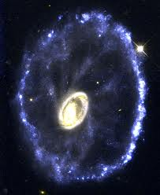
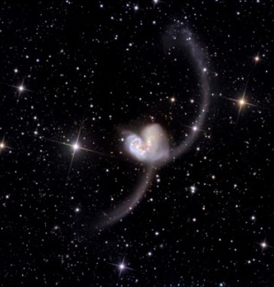
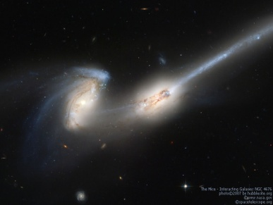

Antennae Galaxy Cartwheel Galaxy Messier 51 Galaxy Mice Galaxy

Galaxy | Peri (kpc) | Red’s Mass | # of Stars | Red Theta | Green Theta | Red Phi | Green Phi | Friction on/off | Halo on/off | Age

Tidal Tails - Tidal tails are the long streamers of stars which are ejected when galaxies collide. These features are caused by a combination of gravitational tidal force and the rotation of galaxies. Remember that the simulation is 3-dimensional, so you can to "grab and rotate" the simulation to see the tails from different viewing angles.

How does the development of the tidal tails change as the mass of the companion changes? (start with the companion mass equal to 1.0, then set the companion mass to larger (10) and smaller (0.1) values and see how the formation of tidal tails changes. Describe how the tails differ for large and smaller values of the companion galaxy’s mass.

How do the tails change as you make the encounter more distant? Reset the companion mass to 1.0, and adjust the pericenter distance to larger and smaller values. Describe below how the formation of tails changes for larger (20 kpc) and smaller (2 kpc) pericenter values.

- information would you

