Supernova in M51

At least two supernovae have been detected in recent years in the nearby Whirlpool Galaxy, Messier 51. M51 is located at a distance of about 31 million light years (about 10 megaparsecs) in the direction of the constellation Canes Venatici.

Stars can explode as supernovae in different ways, and the different explosion mechanisms produce characteristically different behavior of brightness with time, as the supernova brightens and then fades again. The two dominant types of supernovae are Type Ia supernova, which are thought to be exploding white dwarfs, and Type II supernovae, which are explosions of massive stars that run out of nuclear fuel.
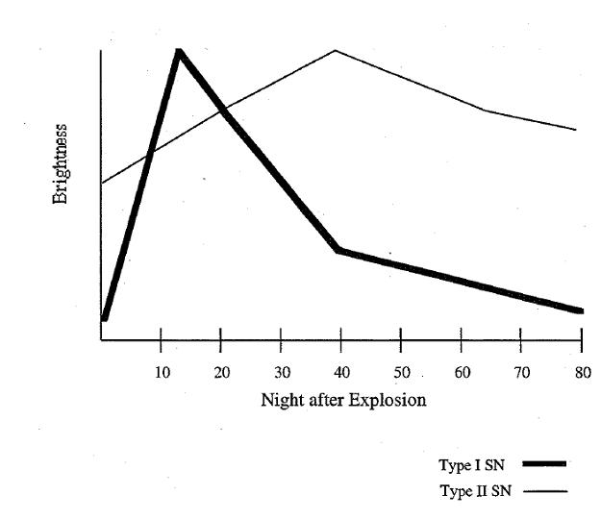
The light curves of supernovae of Type Ia and Type II are compared in the figure below. Type Ia supernova rise to maximum and then fall steadily in brightness, fading in just a few weeks. Type II supernovae remain bright for a longer period of time as energy is provided by the decay of radioactive products produced in the explosion.

From observations of the light curve of SN1994i in M51, determine whether the explosion is a Type Ia (exploding white dwarf) or a Type II (massive star) supernova. The observations were obtained with the Leuschner Telescope between April 2 and May 6 in 1994.

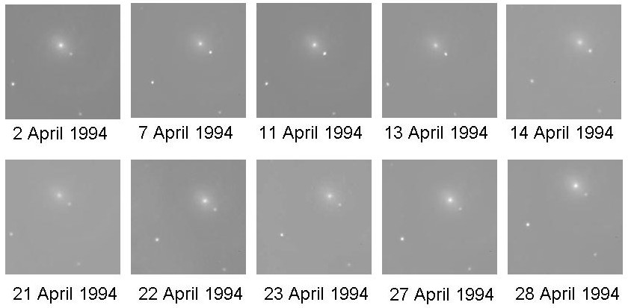

Note: Because sky conditions vary, the brightness of the supernova should be compared to the brightness of the two stars in the image, in the lower left center and lower right.

Does SN1994i appear to be a Type Ia or a Type II supernova? _______________________________

