Classifying Galaxies

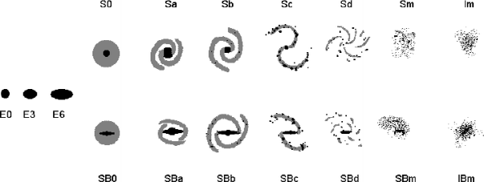

Sketch each of the galaxies shown in the PowerPoint slide, and classify each according to the scheme shown above. Identify whether the stellar population of each is predominantly old or young, and whether each galaxy is gas-rich or gas-poor. In each sketch, identify the major morphological features in the galaxy and indicate how they led to your classification.

Galaxy 1 ______________
Classification________
Old stars Young Stars
Gas-rich Gas-poor

Galaxy 2 _______________
Classification________
Old stars Young Stars
Gas-rich Gas-poor

